Contents

Tested Browser: 1

Page Layout: 2

Changes to the document: 2

Highlights: 3

# Tested Browser:

1. Google Chrome:

I mainly used to google chrome to test all my html and CSS.

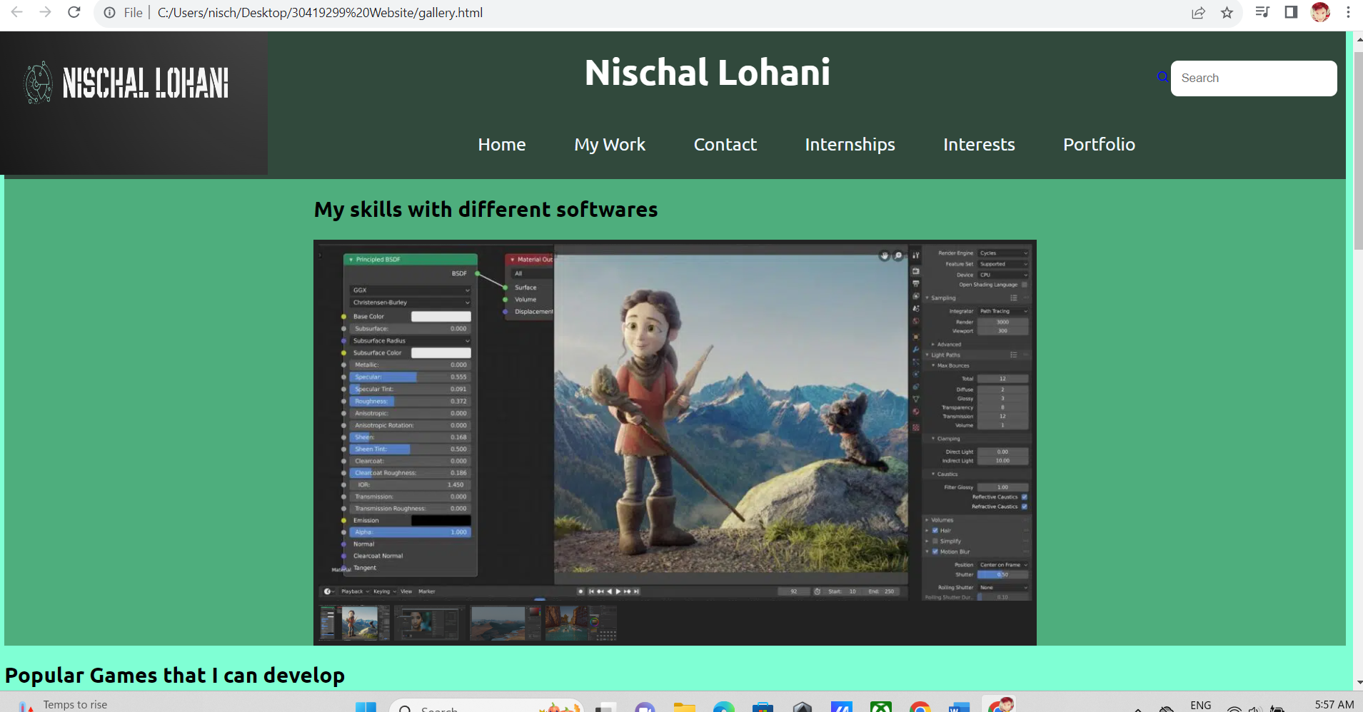

1. Microsoft Edge:

After finishing most of my coding I tested my website on Microsoft Edge and It worked in the same way.

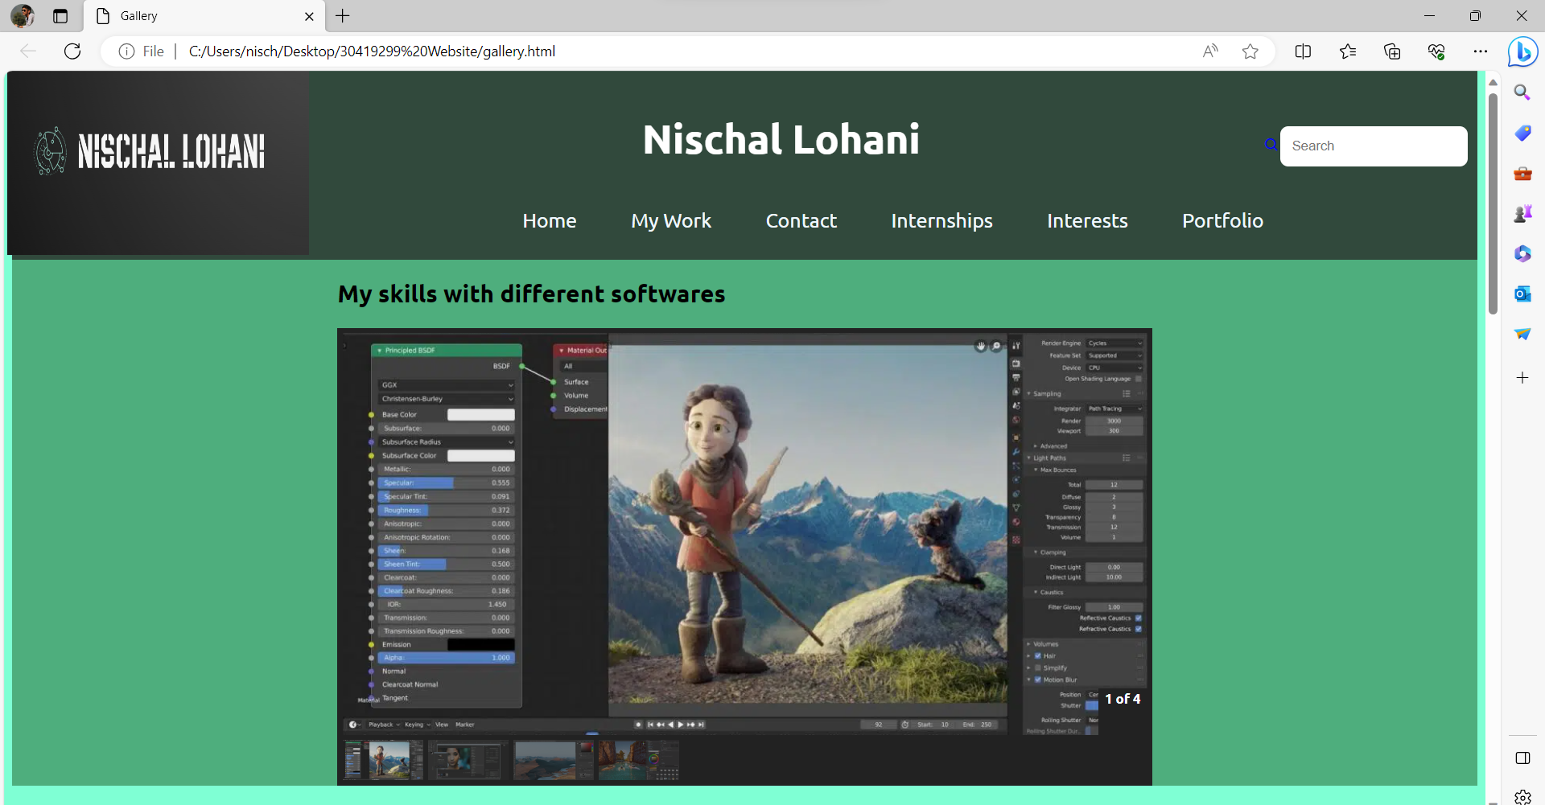

# Page Layout:

I have used flexible layout in my website as I did on my design documentation.

Minimum width:1097px

Optimal Resolution: 1094.4* 2657.68

# Changes to the document:

I have made some major changes on my website because as per the feedback, I did not have many grids on my website which caused my website to look unordered and not symmetrical. I have used grid in almost every pages so that all my content fits perfectly.

* Number of sections in home pages has increased: - I increased this because it will give my website a professional look rather than not scrollable website.
* Addition of grid: - I added grids on most of my webpages so that my content will look organized as well as perfectly fitting.
* Scrollable home page: - I have added 3 more section on my homepage so that my webpage has some extra content.
* Design and Layout changed from wireframe: My wireframe layouts were not perfect for a website as I got less marks in my mock-up. Hence, I changed some designs in most of the pages of my website.

# Highlights:

1. CSS3 visual elements:

* I have used a lot of **grids** in my website to make my webpages look organised and similar.
* I have also used **rounded** **corners** using border-radius in most of my images where they are applicable.
* I have used a lot of **flex** on my website as my website page layout is flexible.
* There are various **multi** **columns** that I have used with the help of grid on my webpages.

1. JavaScript:

I have used java script for my slideshow in the gallery page. I used one of the lab tutorials to use it for the slideshow.

1. Navigation:

I have got a navigation bar with also a dropdown menu, which will give access to 3 more additional webpages.